24 February 2020, No. 37/20

PRESS RELEASE
February 2020

Average after-tax wage in January 914 КМ
The highest average after-tax wage in the section Financial and insurance activities 1,430 КМ; the lowest one in the section Construction 648 КМ

Average monthly after-tax wage in Republika Srpska paid in January 2020 amounted to 914 КМ, while average monthly gross wage was 1,421 КМ.

Average after-tax wage paid in January 2020, compared to the same month of the previous year, was nominally 3.1% higher and really 2.5% higher, while compared to December 2019 it was nominally 2.6% lower and really 3.0% lower.

In January 2020, the highest average after-tax wage, by section of economic activities, was paid in the section Financial and insurance activities and it amounted to 1,430 KM. On the other hand, the lowest average after-tax wage in January 2020 was the one paid in the section Construction 648 KM.

In January 2020, compared to January 2020, the highest nominal increase in after-tax wages was recorded in the section Accommodation and food service activities 12.3%, followed by Arts, entertainment and recreation 11.9% and Wholesale and retail trade; repair of motor vehicles and motorcycles 9.2%.

During the same period, a decrease in nominal wages was recorded in the sections Information and communication 18.5%, Real estate activities 4.9% and Professional, scientific and technical activities 1.7%.

км

Graph 1. Average after-tax wages by month

Monthly inflation 0.5% in January 2020*
Annual inflation (January 2020/January 2019) 0.8%*

Prices of products and services used for personal consumption in Republika Srpska, measured with the consumer price index, in January 2020, compared to the previous month, were on average 0.5% higher, while they were on average 0.8% higher compared to the same month of the previous year.
Of the 12 main divisions of products and services, an increase in prices was recorded in seven divisions, a decrease was recorded in four divisions, while prices in one division remained unchanged.
The highest annual increase in prices in January 2020 was recorded in the division Alcoholic beverages and tobacco, namely by 5.5%, due to higher prices in the group tobacco by 7.0%. An increase in prices was also recorded in the division Recreation and culture, by 2.5%, due to higher prices in the groups travel arrangements by 6.4%, recreation and sport services by 5.8% and major durables for recreation by 5.6%. Higher prices were also recorded in the division Food and non-alcoholic beverages, by 1.6%, due to higher prices in the groups fruit by 14.1%, meat by 3.2% and bread and cereals by 3.0%. An increase in prices by 0.8% at the annual level was recorded in the division Health, due to an increase in the group other medical products by 2.4%, while in the division Housing an increase by 0.7% was recorded due to higher prices in the groups garbage collection by 9.7% and water supply by 5.0%. In the divisions Communication and Restaurants and hotels an increase by 0.5% was recorded.

In the division Education prices remained unchanged on average.

The highest decrease in prices in January was recorded in the division Clothing and footwear, by 10.0%, due to seasonal discounts on ready-made clothing and footwear during the year. A decrease in prices was also recorded in the division Furnishings and household equipment, by 0.5%, due to lower prices in the group large tools and equipment by 4.9%. In the division Other goods and services, a decrease in prices by 0.5% occurred due to discounts in the group personal items by 3.5% and personal care products by 1.8%, while lower prices in the division Transport (0.2%) were recorded in the group bicycles by 3.8% and air transport of passengers by 2.8%.

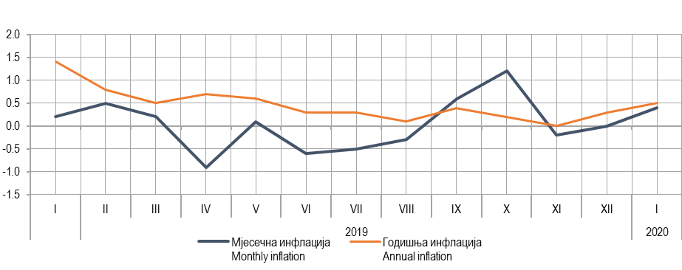
Annual inflation
Monthly inflation
Graph 2. Monthly and annual inflation

Coverage of import with export 83.4% in January 2020

In January 2020, the value of export was 251 million KM, which represented a decrease by 7.0% compared to the same period of the previous year. During the same period, the value of import was 301 million KM, which represented an increase by 1.1% compared to the same period of the previous year.

In the total external trade of Republika Srpska in January 2019, the percentage of coverage of import with export was 83.4%.

In terms of the geographical distribution of external trade of Republika Srpska, in January 2020, the highest value of export was that of export to Croatia, with 41 million KM or 16.5%, followed by Italy, with 37 million KM or 14.7% of the total realised export. During the same period, the highest value of import was that of import form Serbia, with 50 million KM or 16.5%, followed by Italy, with 47 million KM or 15.6% of the total realised import.

By group of products, in January 2020, the highest share in export was that of electricity, with the total value of 25 million KM, which was 9.9% of the total export, while the highest share in import was that of petroleum and oils obtained from bituminous minerals, with the total value of 20 million KM, which was 6.5% of the total import

thous. КМ

export
import
Graph 3. Export and import by month

SYMBOLS

* corrected data

DATA PREPARED BY:

Labour statistics
Biljana Glušac
biljana.glusac@rzs.rs.ba
Prices statistics
Slavica Kukrić
slavica.kukric@rzs.rs.ba
External trade statisticx
Vladimir Lambeta
vladimir.lambeta@rzs.rs.ba

SYMBOLS
∅ - average
¹ - estimate

The Release prepared by the Division for Publications, Public Relations and Statistical Data Confidentiality
Vladan Sibinović, Head of the Division and Editor in Chief
Published by the Republika Srpska Institute of Statistics ,
Republika Srpska, Banja Luka, Veljka Mlađenovića 12d
Prof. Dr. Jasmin Komić, Acting Director
The Release is published online at: www.rzs.rs.ba
telephone +387 51 332 700; e-mail: stat@rzs.rs.ba

Data may be used provided the source is acknowledged

