|  |  |  |
| --- | --- | --- |
| Prvi.jpg | | 22 January 2018, No. **5/18** |
|  |  | |

|  |
| --- |
| PRESS RELEASE |
| **January 2018** |

**Average net wage in December 835 КМ**

**The highest average net wage was that in the section *Financial and insurance activities* 1,310 КМ, while the lowest one was that in the section *Administrative and support service activities* 548 КМ**

Average monthly net wage of employed persons in Republika Srpska paid in December 2017 was835 КМ, while average monthly gross wage was 1,338 КМ.

Average net wage in December 2017, compared to November 2017, was really 0.4% higher.

Average monthly net wage paid in 2017 was 831 KM, while average monthly gross wage amounted to 1,331 KM.

Compared to 2016, average monthly net wage paid in 2017 was nominally 0.6% lower. The decrease occurred mainly due to the correction of wages based on the length of service, in accordance with the new legal solutions.

In December 2017, the highest average wage, by section of economic activities, was paid in the section *Financial and insurance activities* and it amounted to 1,310 KM. On the other hand, the lowest average net wage in December 2017 was the one paid in the section *Administrative and support service activities* 548 KM.

In December 2017, compared to November 2017, the highest nominal increase in net wages was recorded in the sections *Accommodation and food service activities* 7.9%, *Manufacturing* 2.3% and *Other service activities* 2.3%.

The highest decrease in nominal wages was recorded in the sections *Administrative and support service activities* 2.3%, *Education* 2.1% and *Professional, scientific and technical activities* 2.0%.

км



Graph 1. Average net wages of employed persons by month

**Monthly inflation 0.0% in December 2017**

**Annual inflation (December 2017/December 2016) 0.4%**

## Prices of products and services used for personal consumption in Republika Srpska, measures with the consumer price index, in December 2017, compared to the previous month, remained on the average at the same level, while they were on the average 0.4% higher at the annual level.

Of the 12 main divisions of products and services, an increase in prices was recorded in three divisions, a decrease was recorded in four divisions, while prices in five divisions remained on the average at the same level.

The highest increase in prices in December was recorded in the divisions *Transport* (0.8%), due to higher prices in the group fuels and lubricants by 1.2%. Higher prices were also recorded in the divisions *Food and non-alcoholic beverages* (0.2%), mainly in the group vegetables by 7.0% and in the group bread and cereals by 0.4%. An increase in prices in the division *Alcoholic beverages and tobacco* (0.2%) was recorded in the group alcoholic beverages by 1.1%.

In the divisions *Housing*, *Health*, *Communication*, *Education* and *Restaurants and hotels* prices remained on the average at the same level.

The highest decrease in prices in December was recorded in the division *Clothing and footwear* (2.9%), due to seasonal and holiday discounts. Lower prices in the division *Furnishing and other equipment* (0.7%) were recorded in the group household cleaning and maintenance products by 1.4%, in the group furnishing and dwelling equipment by 0.5% and in the group large household appliances by 0.3%, due to various holiday discounts. A decrease in prices in December was also recorded in the divisions *Other goods and services* (0.3%) and *Recreation and culture* (0.2%).

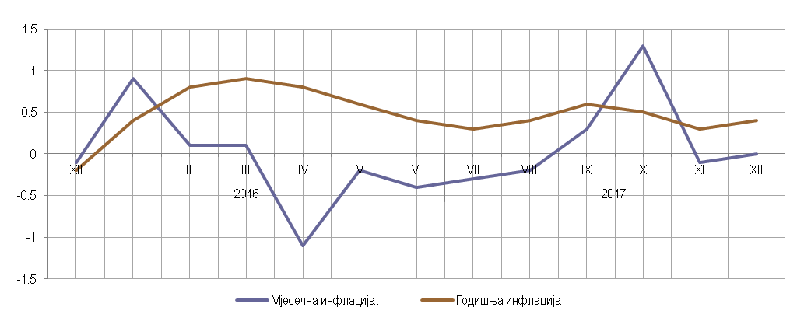

Annual inflation

Monthly inflation

Graph 2. Monthly and annual inflation

**Working-day adjusted industrial production (January-December 2017/January-December 2016) increased by 1.4%**

**Number of employees in industry (January-December 2017/January-December XII 2016) increased by 4.0%**

**Working-day adjusted industrial production** in the period January-December 2017, compared to the period January-December 2016, increased by 1.4%. In the section *Manufacturing* an increase by 6.5% was recorded, while in the section *Mining and quarrying* a decrease by 2.1% was recorded and in the section *Electricity, gas, steam and air-conditioning supply* a decrease by 7.5%. By main industrial group, based on economic purpose of products, working day-adjusted production of capital goods in the period January-December 2017, compared to the same period of 2016, was 20.7% higher, production of intermediate goods was 6.9% higher and production of consumer non-durables was 2.2% higher, while production of consumer durables was 4.1% lower and production of energy was 5.6% lower.

**Number of employees in industry** in December 2017, compared to the average monthly number of employed persons in 2016, was 4.8% higher. Compared to the same month of the previous year it was 2.9% higher, while compared to November 2017 it was 0.5% lower. Number of employees in industry in the period January – December 2017, compared to the same period of 2016, was 4.0% higher. During the same period, in the section *Manufacturing* an increase by 4.2% was recorded, in the section *Mining and quarrying* an increase by 3.3% and in the section *Electricity, gas, steam and air-conditioning supply* an increase by 3.1%.

Trend indices

Seasonally adjusted indices

Graph 3. Indices of industrial production, December 2013 – December 2017 (∅2010=100)

**Coverage of import with export (in the period January-December 2017) 71.6%**

In December 2017, the value of export was 291 million KM and the value of import was 377 million KM.

In the total external trade of Republika Srpska in December of the current year, the percentage of coverage of import with export was 77.3%.

In the period January-December 2017, the value of export was three billion and 477 million KM, which represented an increase by 21.2% compared to the same period of the previous year. During the same period, the value of import was four billion and 858 million KM, which represented an increase by 9.7% compared to the same period of the previous year.

The coverage of import with export in the period January-December 2017 was 71.6% and it represents the highest coverage of import with export recorded in the course of one year in the history of Republika Srpska. In 2016, the coverage of import with export was 64.8%.

In terms of the geographical distribution of external trade of Republika Srpska, in the period January – December 2017, the highest value of export was that of export to Italy, with 530 million KM or 15.3%, followed by Croatia, with 463 million KM or 13.3% of the total realised export. During the same period, the highest value of import was that of import form Serbia, with 845 million KM or 17.4%, followed by Russia, with 629 million KM or 12.9% of the total realised import.

By group of products, in the period January – December 2017, the highest share in export was that of electricity, with the total value of 247 million KM, which was 7.1% of the total export, while the highest share in import was that of petroleum and oils obtained from bituminous minerals (crude), with the total value of 572 million KM, which was 11.8% of the total import.

thous. КМ

export

import

2016

2017

Graph 4. Export and import by month

|  |
| --- |
| **DATA PREPARED BY:** |
| **Labour statistics**  Biljana Glušac  [biljana.glusac@rzs.rs.ba](mailto:biljana.glusac@rzs.rs.ba) |
| **Prices statistics**  Željka Drašković  [zeljka.draskovic@rzs.rs.ba](mailto:zeljka.draskovic@rzs.rs.ba) |
| **Industry and mining statistics**  Biljana Jeličić  [biljana.jelicic@rzs.rs.ba](mailto:biljana.jelicic@rzs.rs.ba) |
| **External trade statistics**  Sanja Stojčević Uvalić, MSc  sanja.stojcevic@rzs.rs.ba |

|  |
| --- |
| **SYMBOLS** |
| **∅** - average  ¹ - estimate |

|  |
| --- |
|  |
| The Release prepared by the Division for Publications, Public Relations and Statistical Data Confidentiality |
| Vladan Sibinović, Head of the Division and Editor in Chief  Published by the Republika Srpska Institute of Statistics ,  Republika Srpska, Banja Luka, Veljka Mlađenovića 12d  Radmila Čičković, PhD, Director General of the Institute  The Release is published online at: www.rzs.rs.ba  telephone +387 51 332 700; E-mail: stat@rzs.rs.ba  **Data may be used provided the source is acknowledged** |